**Project 1: Deploying a web server in Ubuntu instance**

**Task 1:** Create a Ubuntu instance using AMI: Ubuntu Server 18.04 LTS (HVM)

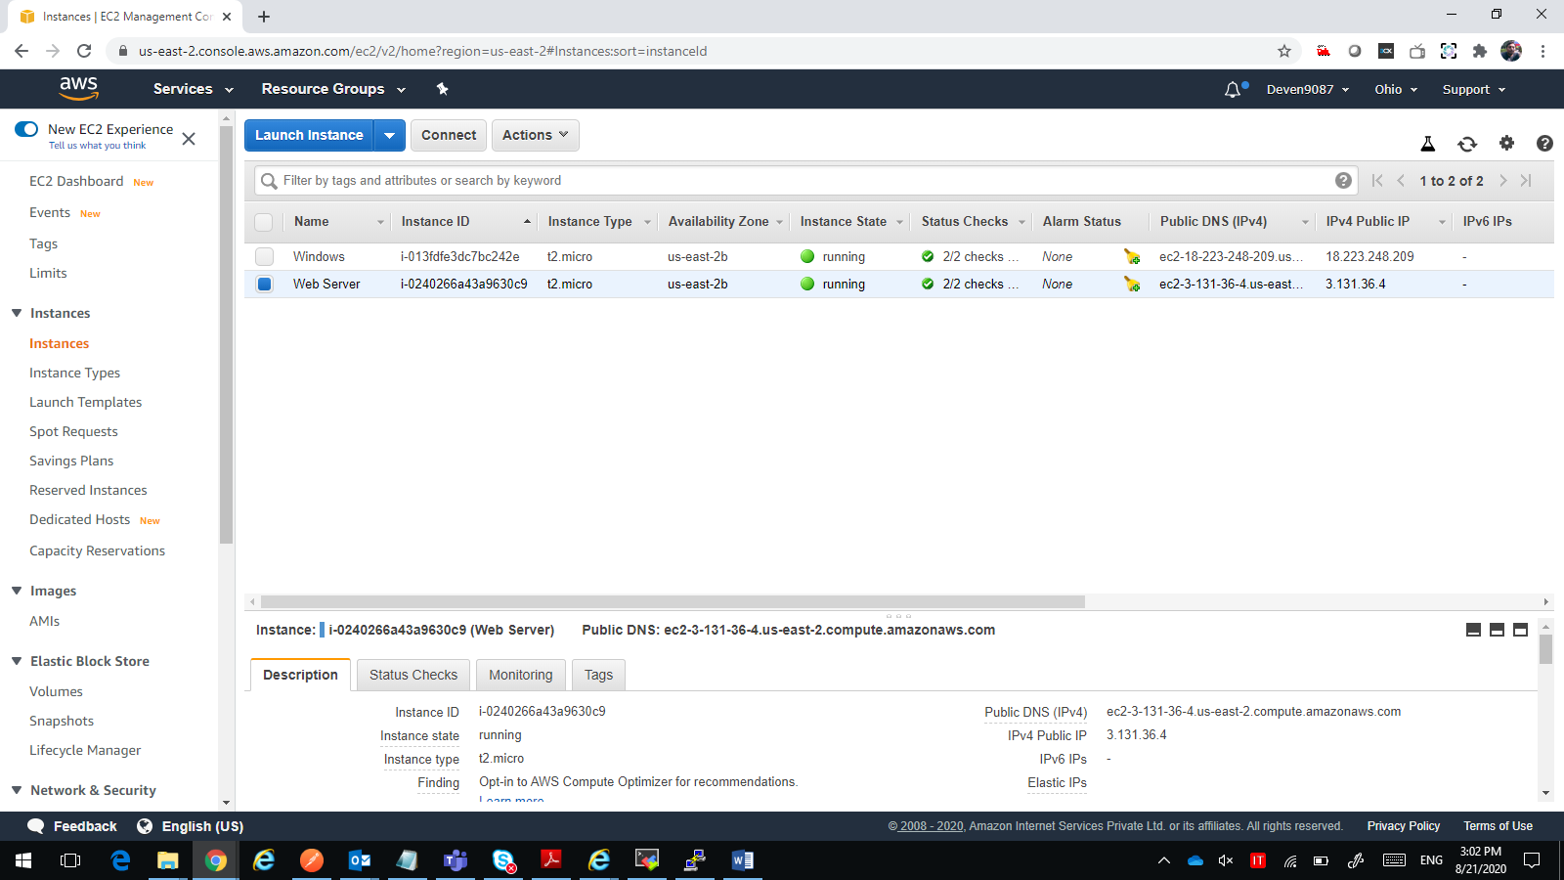

**Task 2:** Download and install MobaXterm Portable Edition

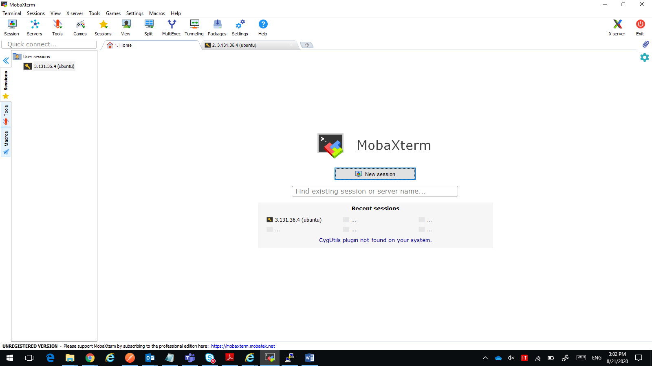

**Task 3:** Launch the Ubuntu instance using SSH

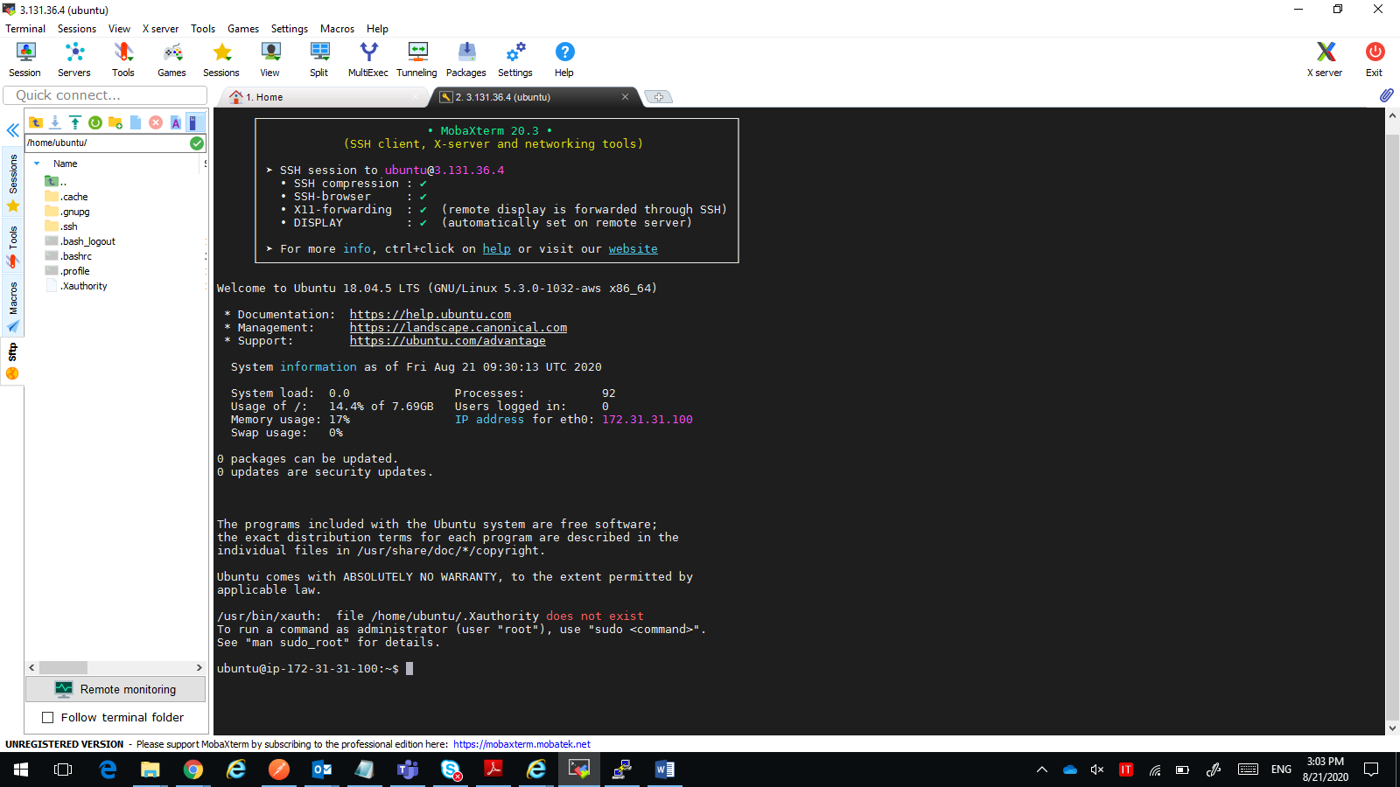

**Task 4:** Install ngnix web server using bash

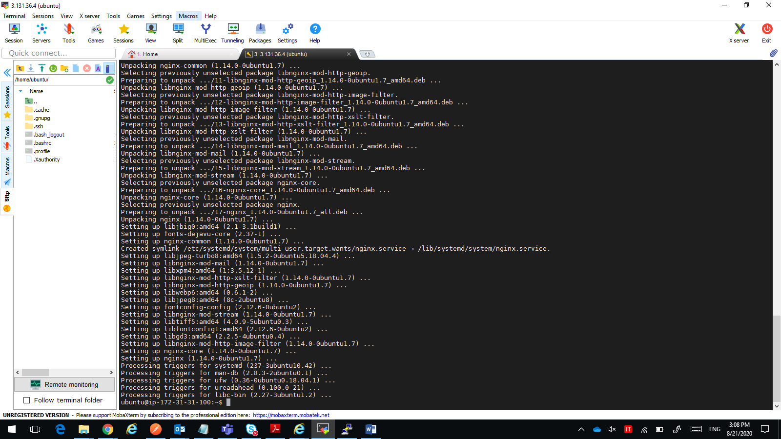

**Task 4:** Verify successful installation of ngnix

